

Alternative Assessment Tool (AAT) Report on

“Design and Verification of Combinational and
Sequential Digital Modules using Verilog HDL”

Submitted in partial fulfilment of the requirements of the Alternative Assessment Tool
(AAT) for the course

ADVANCED DIGITAL AND LOGIC DESIGN (ADLD)
[Course Code: 23ECSPE1AD]

Submitted by

S SOUPARNIKA 1BF24EC126

Submitted to

Prof. Ajaykumar Devarapalli

DEPARTMENT OF ELECTRONICS AND COMMUNICATION ENGINEERING
BMS College of Engineering
Bull Temple Road, Basavanagudi, Bengaluru-560019

Academic Year
2026 – 2027
INDEX

S.NO | CONTENTS |  | PAGE NO
 | Introduction
1 | Comparator | 4-6
2 | Shift register | 7-9
3 | Conclusion | 10

INTRODUCTION

Cadence is an Electronic Design Automation (EDA) tool used for designing, simulating, verifying and implementing integrated circuits (ICs). It plays an important role in VLSI design by providing an environment for schematic creation, circuit simulation and physical layout design.
Cadence Virtuoso is widely used for analog and digital circuit design. It allows designers to create circuit schematics, perform simulations, analyse circuit behaviour and generate layouts. It also provides verification tools such as Design Rule Check (DRC) and Layout Versus Schematic (LVS) to ensure accurate IC design.
Cadence tools help improve design accuracy, reduce development time and support the development of efficient integrated circuits.
Applications
- VLSI circuit design.
- Schematic design and simulation.
- CMOS circuit implementation.
- IC layout design.
- Circuit verification and testing.
Tools Used
- Cadence Virtuoso
- Spectre Simulator
- Analog Design Environment (ADE)
- DRC and LVS

Comparator

WORKING PRINCIPLE
A 4-bit comparator is a combinational circuit used to compare two 4-bit binary numbers A and B. It checks whether A is greater than, less than or equal to B and produces the corresponding output. If A is greater than B, A_gt_B becomes HIGH; if A is less than B, A_lt_B becomes HIGH; and if both inputs are equal, A_et_B becomes HIGH. Only one output is HIGH at a time. It is commonly used in digital systems, processors and arithmetic logic units.

CODE:

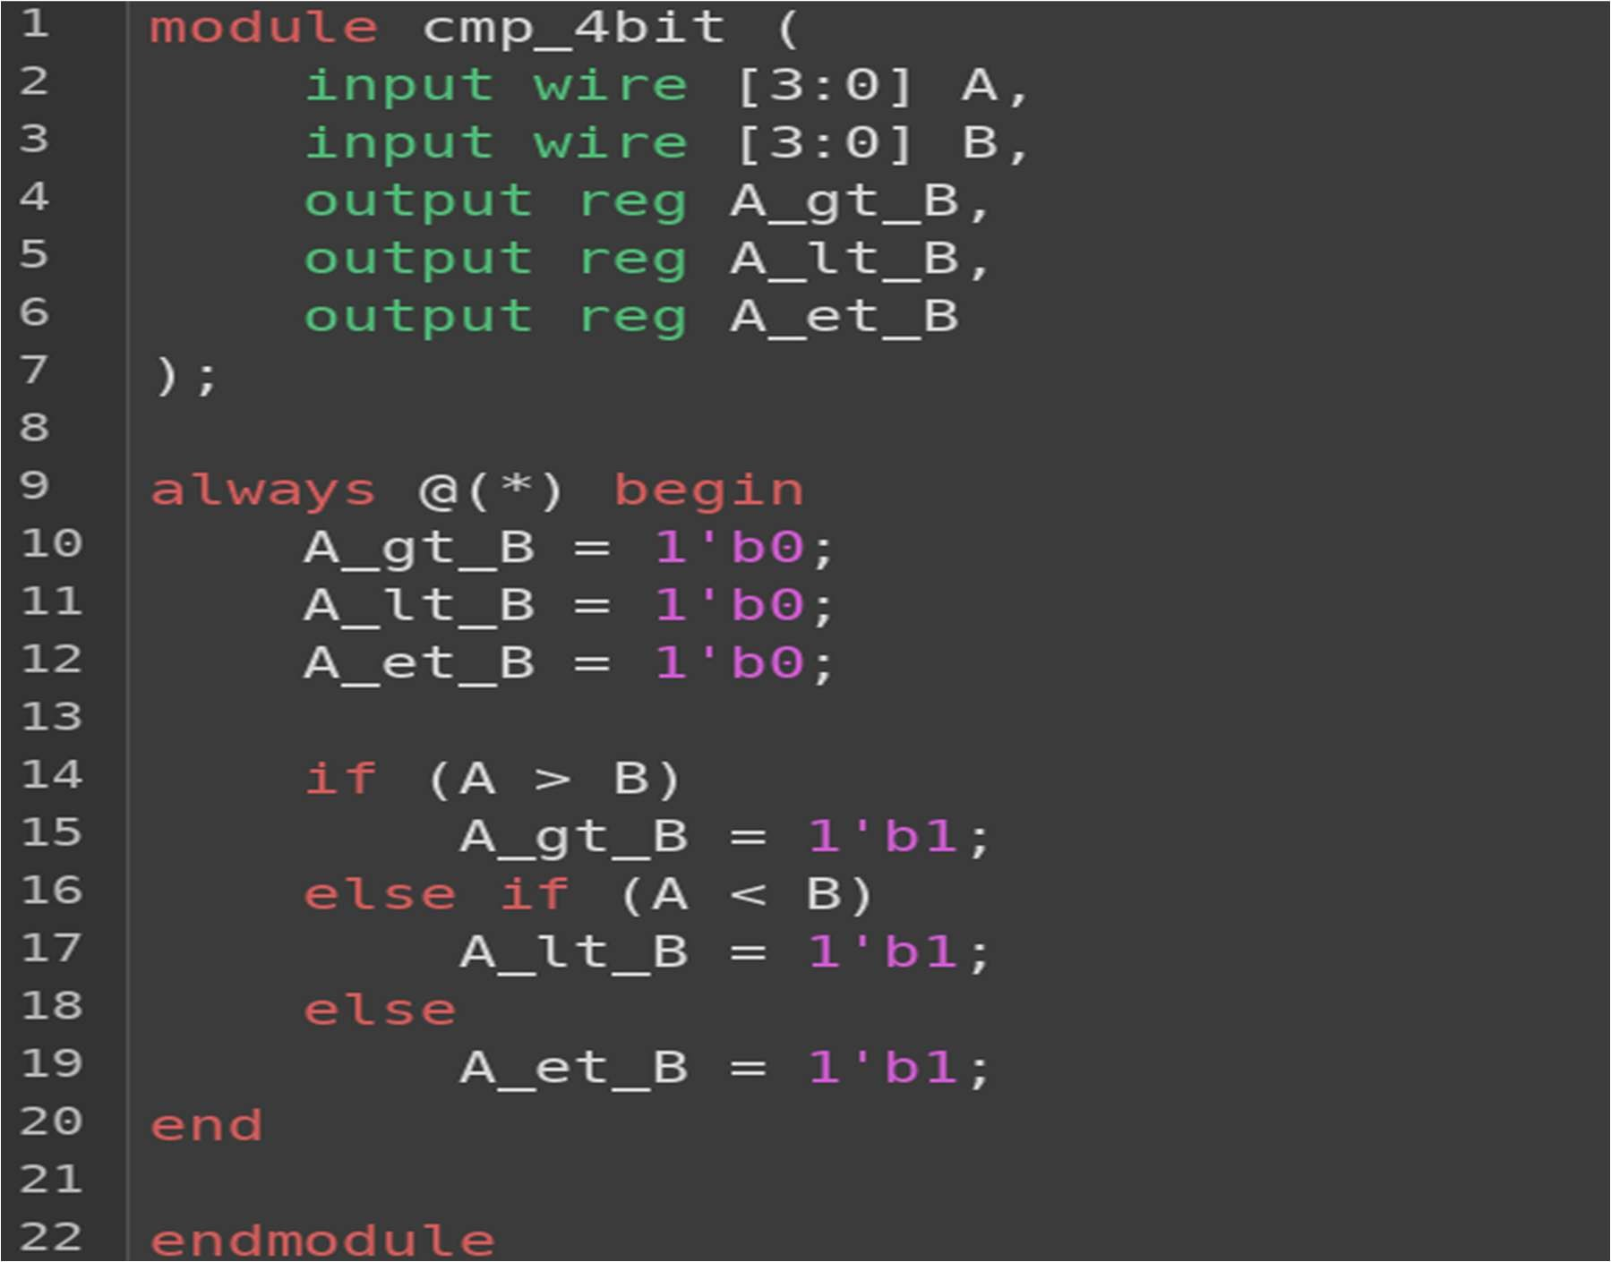
TESTBENCH:

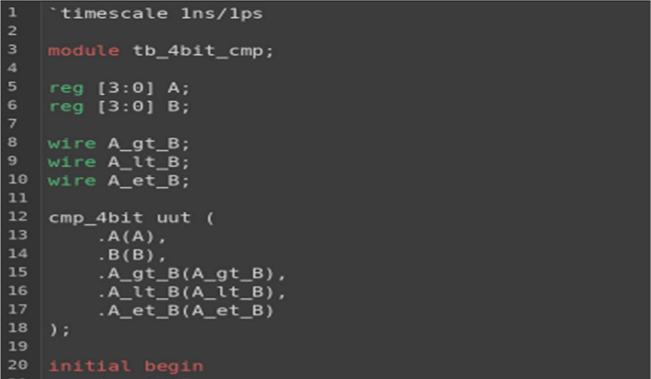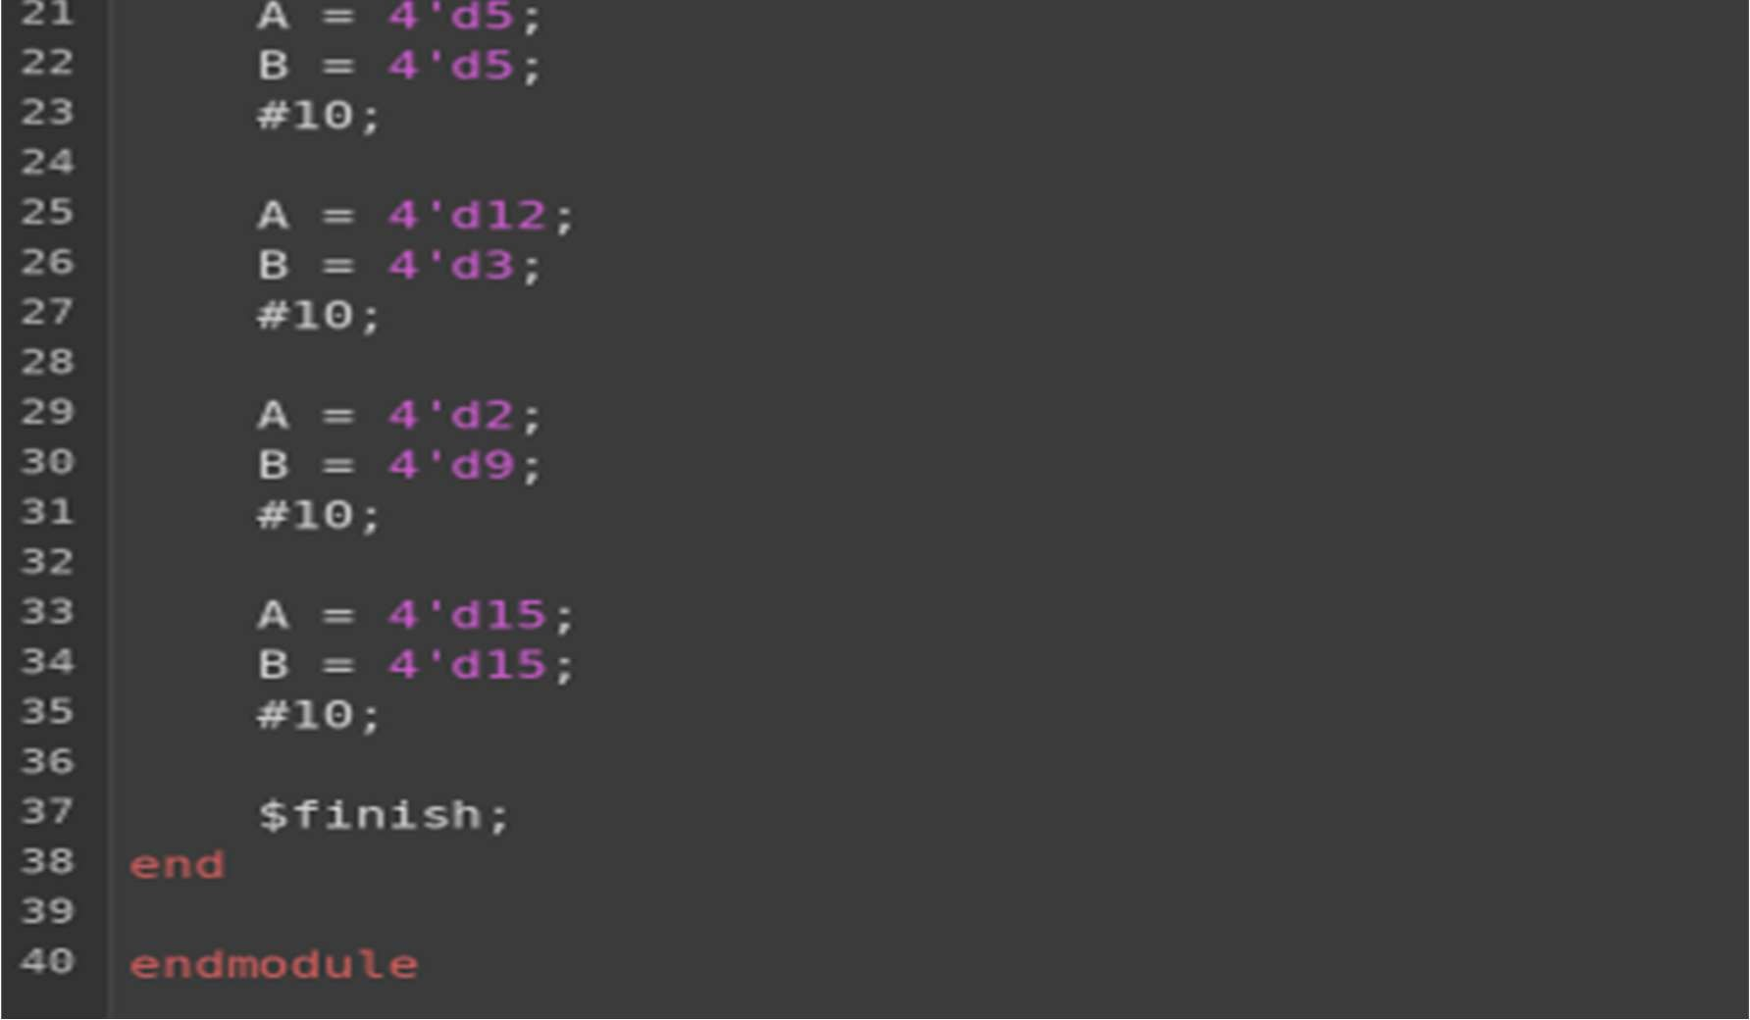

OUTPUT WAVEFORM:

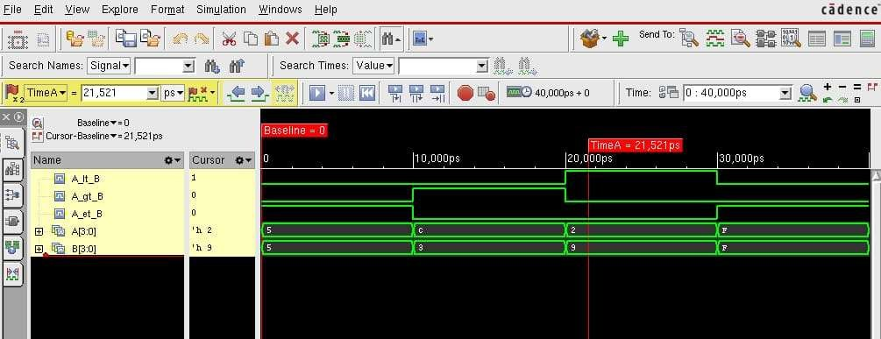

Shift Register

Working Principle
The universal shift register operates based on the positive edge of the clock signal. Whenever a rising edge of the clock occurs, the circuit checks the reset signal and the two-bit selection input to determine the operation to be performed. If the reset signal is active, all four output bits are cleared to zero immediately, without waiting for a clock edge. Otherwise, the circuit performs the operation specified by the selection inputs.
The two-bit selection input, sel, determines the mode of operation. When sel = 00, the register holds its previous value without making any changes. When sel = 01, the register performs a right-shift operation, in which the existing bits move one position to the right and the new most significant bit is supplied by serial_in_right. When sel = 10, the register performs a left-shift operation, in which the existing bits move one position to the left and the new least significant bit is supplied by serial_in_left. When sel = 11, the register performs parallel loading, in which all four bits from data_in are loaded into the register simultaneously

CODE:

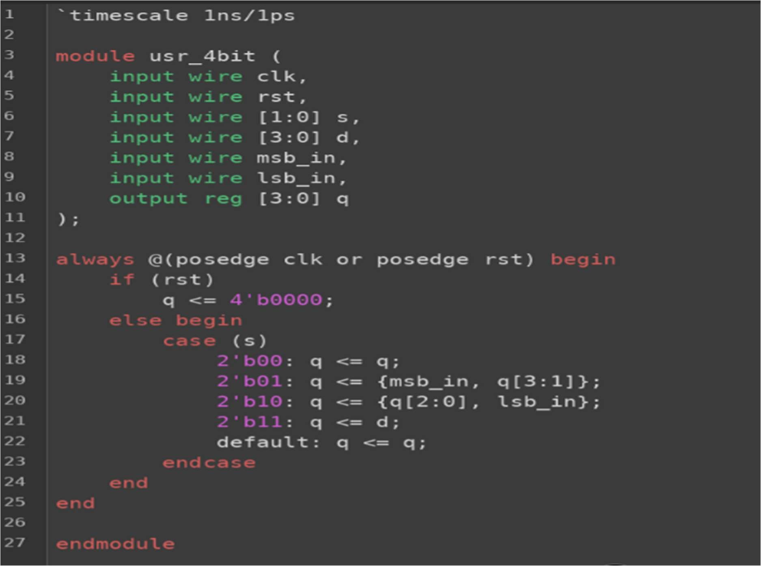
TESTBENCH:

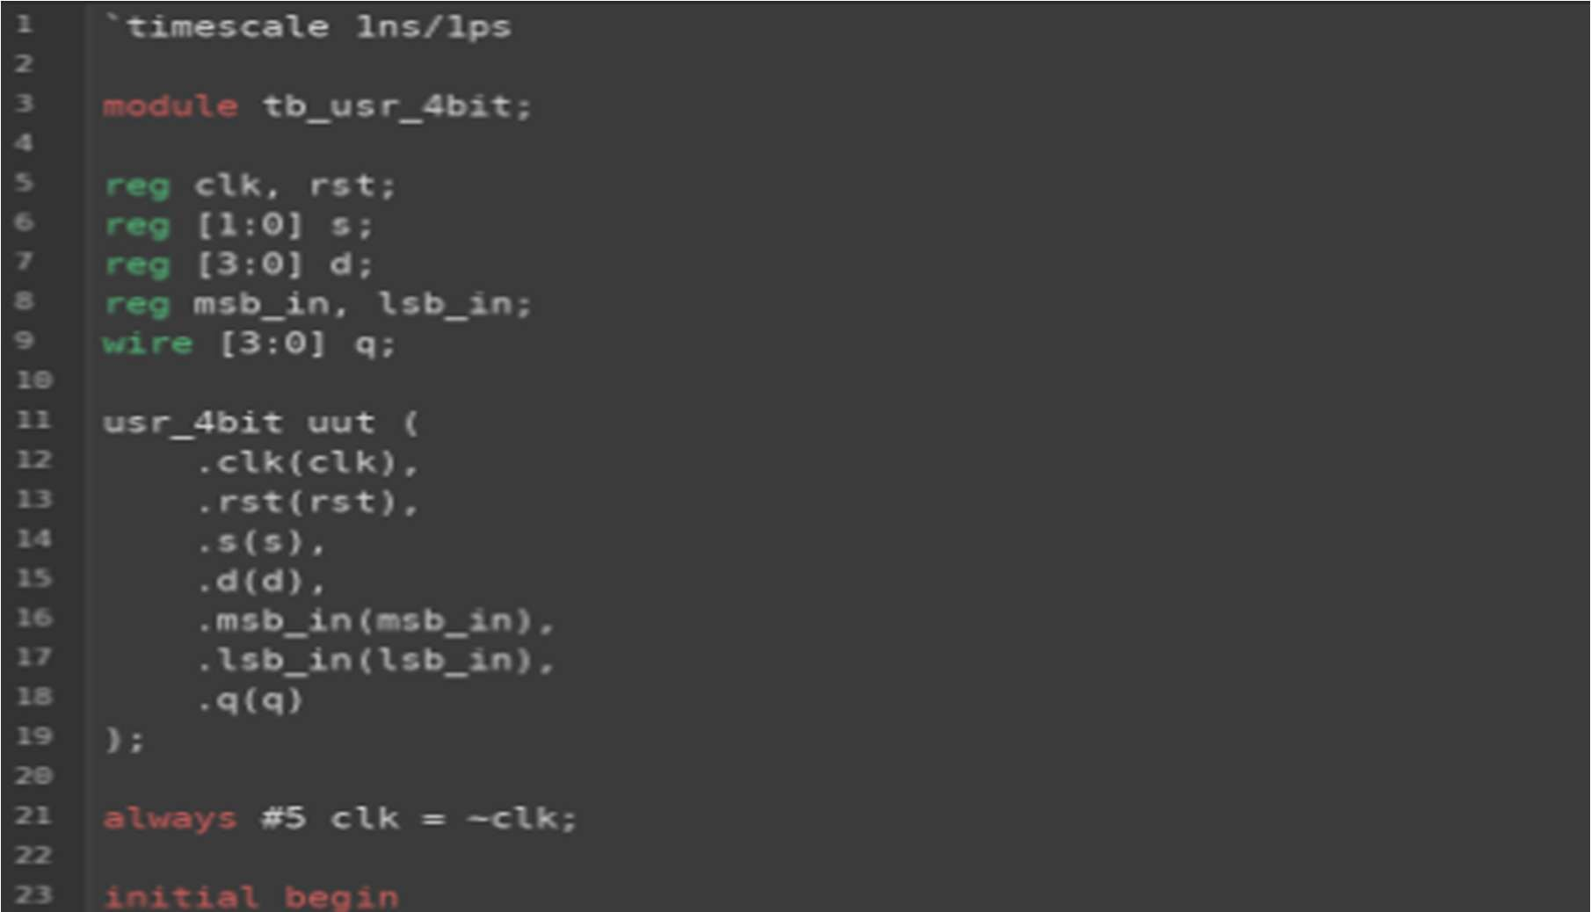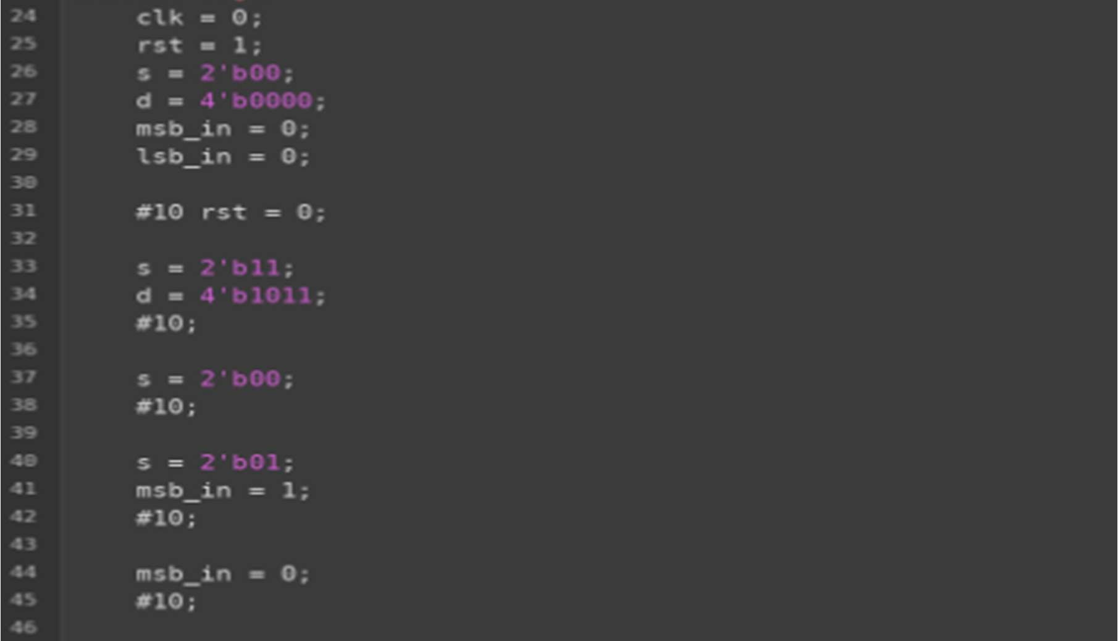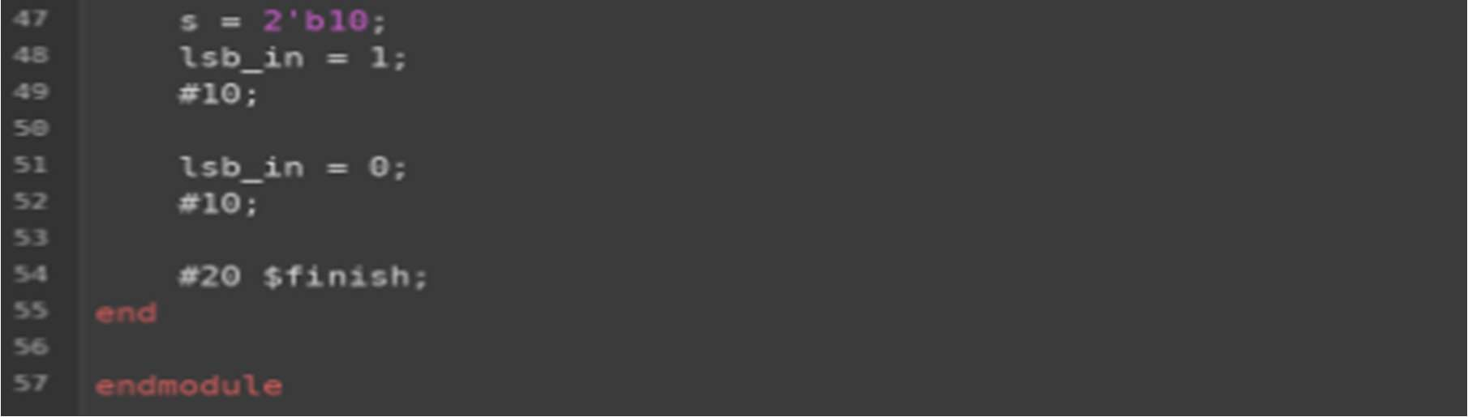

OUTPUT WAVEFORM:

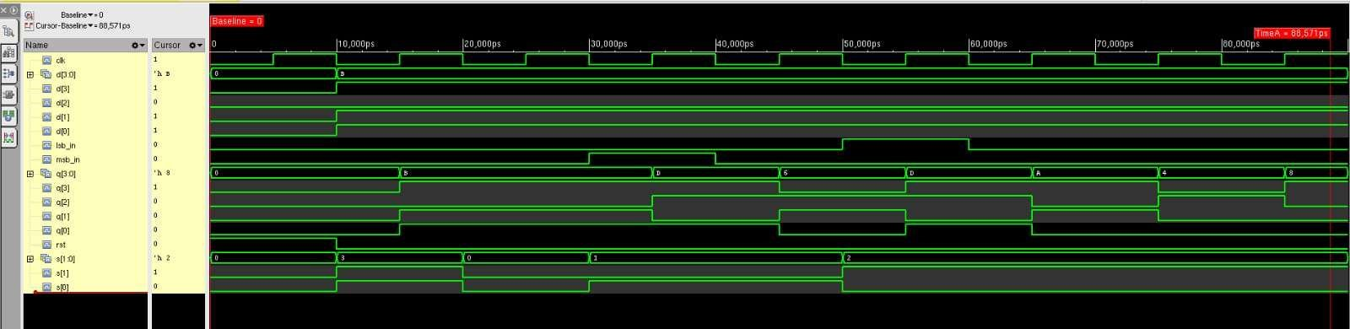

CONCLUSION

Thus, the 4-bit Comparator and 4-bit Universal Shift Register were successfully designed and simulated using Verilog HDL in Cadence. The comparator compares two 4-bit binary inputs and indicates whether A is greater than, less than or equal to B, while the universal shift register performs hold, shift right, shift left and parallel load operations based on the selection inputs. The functionality of both circuits was verified successfully through simulation for different input combinations.

